Network lab logbook – week 2
1. Measurements
Measuring circuit 1: measuring alternating current and alternating current with a multimeter.
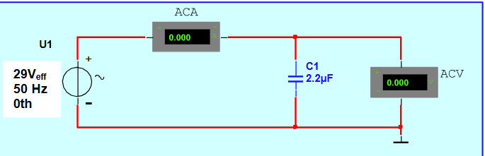
 | I() | UC() | Resistance X ()
A1 | 0.020A | 29V | 1447 Ω
A2 | 20.16mA | 29.16V | 1446.4 Ω
A3 | 40.01mA | 29.19V | 729.5 Ω
A4 | 10.09mA | 29.12v | 2885.4 Ω

Measuring circuit 2: Measuring voltage with the oscilloscope.
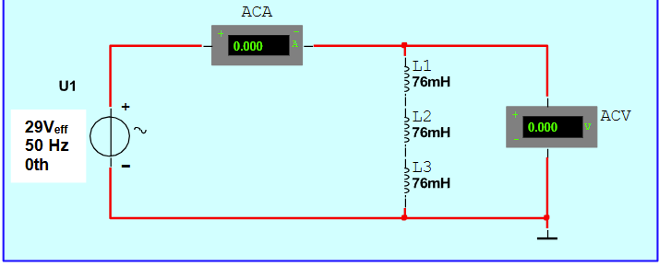
Using the oscilloscope: inifinityVision DSO-X 2024A Digital Storage 200MHz 2GSa/s

 | I1() | UL() | Resistance X ()
B1 | 0.441A | 0.015V | 0.034 Ω
B2 | 0.228A | 0.013V | 0.057 Ω
B3

Conclusion: Coils in parallel.
SKIP EXERCISES 2 AND 3 BECAUSE OF TEACHER ORDER.

